On boarding
When entering the company for the first time, some courses are needed to be taken.

Learning Oracle
First courses to take: we will need to log in onto Learning Oracle
Then we press home, and on search catalog:
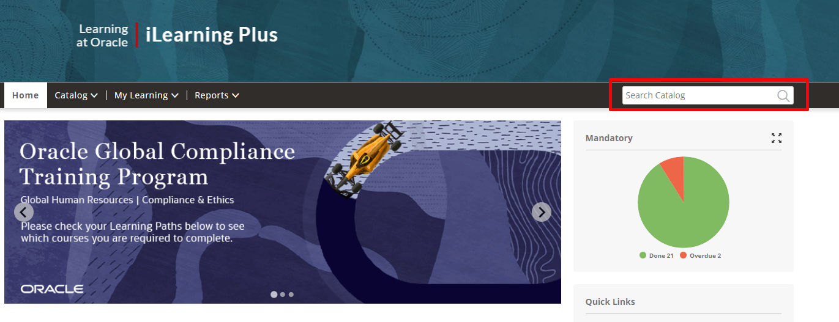
We search for the following trainings and inside of them we take courses attached:
- Global Compliance Training FY23 Global Employees and Managers no US Direct Report.
  - Employee Code of Ethics and Business Conduct
  - Respectful and Inclusive Interactions
- Global Compliance Training New Hire Employees located outside the US FY22
  - Oracle Information Protection Awareness for New Hires
  - Anti-Corruption Training for New Hires
  - Conflicts of Interest Training for New Hires
  - Environment, Health and Safety Awareness for New Hires
  - Insider Trading
  - Oracle Code of Ethics and Business Conduct for New Hires
  - Unconscious Bias for New Hires
  - Global Workspace Harassment Awareness for New Hires (Non-US Employee Edition)
  - Global Antitrust and Competition Law Training
- Global Compliance Training Program: FY23 Survey Questions
- Global Workplace Harassment Awareness for New Hires (Non-US Employee Edition)
- Global Workplace Harassment (Non-US Employee Edition)
- OSSA Global Consulting Core
  - Oracle Software Security Assurance (OSSA)
    - Oracle Software Security Assurance Refresher (If you take OSSA training this course will be marked as completed)
  - Consulting Information Security Awareness Training
Take the following learning paths and assessments inside of them:
- NetSuite OSSA for Delivery Learning Path
  - Core
    - Oracle Software Security Assurance (OSSA)
    - Consulting Information Security Awareness Training
  - Core - Secure Coding Fundamentals for Consulting and Professional Services
    - Resource: Basic Practices for Secure Development of Cloud Applications Part 1 of 2
    - Resource: Basic Practices for Secure Development of Cloud Applications Part 2 of 2
    - Resource: Auth 101: A Passwords Backgrounder for Everyone
  - Electives - Secure Coding Fundamentals for Consulting and Professional Services
    - Resource: An Introduction to Windows Access Controls
    - Resource: File Permissions 101: Linux and OS X
    - Resource: System Hardening 101
  - Assesment - Secure Coding Fundamentals for Consulting and Professional Services
    - Secure Coding Fundamentals for Consulting and Professional Services - Assessment
  - NetSuite Core
    - NetSuite OSSA Guidance and Best Practices
- Secure Coding for Consulting and Professional Services (OSSA)
  - Core - Secure Coding for Consulting and Professional Services
    - Resource: Secure Java Programming 101
    - Resource: Injections 101: SQL and Beyond
    - Resource: Cross Site Scripting (XSS) 101
    - Resource:: CSRF 101: Cross Site Request Forgery for Everyone (Safecode)
  - Assessment - Secure Coding for Consulting and Professional Services
    - Assessment - Secure Codin
The following certification needs to be taken:
- NSGBU General Information Security Awareness
Some useful knowledge-check courses for development needed to be taken:
- Getting Started with Extensions-KC
- Getting Started with Themes-KC
- Developer Tools_KC
- SuiteCommerce Configuration_KC
- SuiteCommerce Web Store Administration - Student Guide
- SuiteKnowledge Contributor Exam
- SuiteKnowledge Publisher Exam
- Web Site Setup_KC
New Hire Onboarding Internal Processes For Delivery

Development
Courses to learn how to develop on NetSuite:
SuiteScript Development
SuiteCommerce Themes and Extensions Development
SuiteCommerce Web Store Administration

Open Air
We use OpenAir to log work hours on project, practices and to give a prediction of hours that we will be working during following weeks.
I recommend you take the following courses:
NetSuite OpenAir Essentials
NetSuite Open Air Reporting
Some useful information in order to interact properly with Netsuite:
How do I create Inventory Items
How do I setup a new Customer
How do I navigate NetSuite
How do I Transfer or Adjust Inventory
Creating Saved Searches
Inventory Adjustments
Create Items and Item Groups
Ideally, you should get SuiteFoundations certification through the course of the year:
Netsuite Certification SuiteFoundation Exam Preparation

